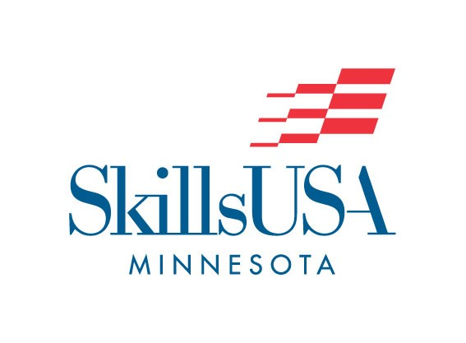

SkillsUSA Minnesota
Advisor of the Year

This form is your opportunity to honor one of your colleagues or teachers. Minnesota will continue to select an Advisor of the Year (AOY) for both its secondary/high school and post-secondary/college divisions. State winners will be announced during the SLSC Skills Conference Awards ceremony, and then submitted for Regional and National Competition.

CRITERIA:
This award will be presented to a SkillsUSA Advisor/educator involved in Trade, Industrial, Technical, or Health Occupations courses; and who have achieved prominence at the local, state, and/or national levels. Two (2) state awards - one (1) Regional and one (1) National - will be presented annually.

ELIGIBILITY:
Individuals who are currently employed as full-time classroom, laboratory, and/or co-op coordinators in a vocational-technical education program, or persons who are not classroom teachers, but have been designated by their school administration as a SkillsUSA Advisor (coordinator) for their school, are eligible recipients for this award. Contributions and achievements with SkillsUSA on which the nomination is based must have been within the past ten (10) years. The nominee must be a paid professional member of SkillsUSA, and have at least three (3) years experience as an advisor/teacher.

NOMINATION:
To nominate an advisor, please complete the following form. Submit the form and a maximum of two (2) letters of additional support/recommendation for the nominee. Nomination forms and letter can be submitted electronically* to: executive.director@mnskillsusa.org (use AOY Nomination in the subject line), or physical copies via mail to:
SkillsUSA MN
Attn: AOY Nomination
4601 Deans Lake Blvd.
Shakopee, MN 55379

*You will need to either “Make a Copy” of, or “Download” this file before being able to edit/insert text. Both of these options are available in the ‘File’ option of the menu.

DEADLINE:
The deadline for AOY nomination forms is March 1st of the current academic year. Please ensure nomination forms and recommendation letters are submitted electronically no later than 11:59pm of March 1st, and all physical nomination forms should be postmarked no later than March 1st.

SkillsUSA Minnesota
Advisor of the Year Nomination Form

Nominee Name:

Home Address:

Nominee’s Affiliated School Address:

Phone #:
Home:
School:

Email:

Division (circle/highlight one):

High School/Secondary College/Post-secondary

Number of Years as an Advisor:

*********************************************************
Nominator’s Name:

Nominator’s Title (i.e. Student Member, Advisor, State Officer, etc.):

Nominator’s Affiliated School & Address:

Nominator’s Contact Information:
Phone:
Email:

Outstanding Contributions and Achievements of Nominee
Please use the space below to outline any contributions or achievements of the nominee that have advanced SkillsUSA Minnesota in the nominee’s School, Region, and/or Nation. You may also include a description of how the nominee has advanced vocational education in his/her occupational area.

Significant Positions Held (in education or SkillsUSA):

Honors/Recognition:

Professional Memberships (include any offices held):

Other specialized SkillsUSA activities such as; community service, CEP, safety projects, or any other activity you consider to go above and beyond the duties of being SkillsUSA MN Advisor:

